Beyond Civility
An online event sponsored by Civility First*
Saturday, October 15, 2022
At 6:00 p.m. PDT
What if:
- There is a type of civility that would make it possible to treat each other with respect without giving up our own beliefs and opinions?
- There is a way to talk across political lines without demonizing the other side?
- We could find solutions to problems without being disloyal to “our side?”

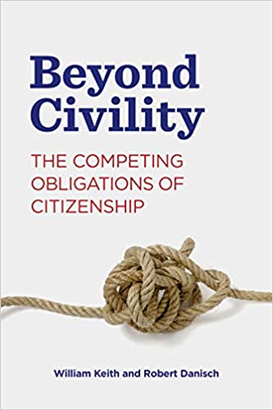
Join Civility First for a conversation with William Keith and Robert Danisch as they discuss their new book, Beyond Civility: The Competing Obligations of Citizenship.
We’ll learn:
- The difference between “Weak Civility” and “Strong Civility.”
- Whether the torn social fabric of our country can be mended.
- If “Radical Civility” is a practice whose time has finally come, or one that should be abandoned as “old school” and irrelevant.
- How communication is more than just downloading information from one person to another. (Hint: It’s really about relationship!)
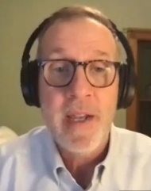
William Keith is Professor of Rhetoric at the University of Wisconsin–Milwaukee. He is the author of the award-winning Democracy as Discussion: Civic Education and the American Forum Movement and coauthor of two highly regarded textbooks, The Essential Guide to Rhetoric and Public Speaking: Choices and Responsibility.
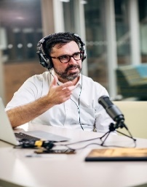
Robert Danisch is Professor of Communication Arts at the University of Waterloo. He is the author of two monographs and a popular book on communication practices, and the host of the communication skills podcast “Now We’re Talking.”
David Frank is an emeritus professor of rhetoric at the University of Oregon. He has joined the Keith-Danisch team to help promote their vision of “strong civility” they set forth in their book Beyond Civility. He is the author of 50 journal articles and eleven books on topics related to rhetoric and civility.
THIS IS A ZOOM EVENT
Rsvp to civility1st@gmail.com or at our website www.civilityfirst.org and we will send the link on the day of the event

